A
MINOR PROJECT REPORT ON
REAL TIME RESEARCH PROJECT ON
Machine Learning and End-to-end Deep Learning for the Detection of Chronic Heart Failure from Heart Sounds
Submitted in partial fulfilment for the award of the degree of

BACHELOR OF TECHNOLOGY

In

COMPUTER SCIENCE AND ENGINEERING ARTIFICIAL INTELLIGENCE AND MACHINE LEARNING

By
B. SNEHA : 22Q91A66D4
B. AKASH : 22Q91A66D5
A. BHUVAN : 22Q91A66D3
N. PARTHIBAN : 22Q91A66G9

Under the guidance of
DR.ATHIRAJA
Professor, Dept. of CSM


DEPARTMENT OF COMPUTER SCIENCE & ENGINEERING ARTIFICIAL INTELLIGENCE AND MACHINE LEARNING MALLA REDDY COLLEGE OF ENGINEERING
(Approved by AICTE-Permanently Affiliated to JNTU-Hyderabad) Accredited by NBA & NAAC, Recognized section 2(f) & 12(B) of UGC New Delhi ISO
9001:2015 certified Institution
Maisammaguda, Dhulapally (Post via Kompally), Secunderabad- 500100 2023 - 2024

MALLA REDDY COLLEGE OF ENGINEERING
(Approved by AICTE-Permanently Affiliated to JNTU-Hyderabad)
Accredited by NBA & NAAC, Recognized section 2(f) & 12(B) of UGC New Delhi ISO
9001:2015 certified Institution
Maisammaguda, Dhulapally (Post via Kompally), Secunderabad- 500100


DEPARTMENT OF COMPUTER SCIENCE & ENGINEERING ARTIFICIAL INTELLIGENCE AND MACHINE LEARNING
CERTIFICATE
This is to certify that the Major Project report on “MACHINE LEARNING AND END TO END DEEP LEARNINF FOR DETECTION OF CHRONIC HEART FAILURE “ is successfully done by the following students of Department of Computer Science & Engineering (Artificial Intelligence and Machine Learning) of our college in partial fulfilment of the requirement for the award of B.Tech degree in the year 2023-2024. The results embodied in this report have not been submitted to any other University for the award of any diploma or degree. B.SNEHA :22Q91A66D4
B.AKASH :22Q91A66D5
A.BHUVAN :22Q91A66D3
N.PARTHIBAN :22Q91A66G9

Submitted for the viva voice examination held on:

INTERNAL GUIDE HOD
Dr.ATHIRAJA Dr.VIGNESH JANARTHANA
PROFESSOR, DEPT OF CSM PROFESSOR

INTERNAL EXAMINER EXTERNAL EXAMINER

DECLARATION
We, B.SNEHA, B.AKASH, A.BHUVAN, N.PARTHIBAN, with Regd.no.22Q91A66D4
, 22Q91A66D5, 22Q91A66D3, 22Q91A66G9 are hereby declaring that the major project report entitled “” has done by us under the guidance of Dr ATHIRAJA Professor, Department of Computer Science Engineering (Artificial Intelligence and Machine Learning) is submitted in the partial fulfilment of the requirements for the award of degree of BACHELOR OF TECHNOLOGY in COMPUTER SCIENCE AND ENGINEERING ARTIFICIAL INTELLIGENCE AND MACHINE LEARNING.
The Results embedded in this project report have not been submitted to any other University or institute for the award of any degree or diploma.

Signature of the Candidate

B. Sneha : 22Q91A66D4
B. Akash : 22Q91A66D5
A. Bhuvan : 22Q91A66D3
N. Parthiban : 22Q91A66G9

DATE:
PLACE: Maisammaguda

ACKNOWLEDGEMENT

First and foremost, we would like to express our immense gratitude towards our institution Malla Reddy College of Engineering, which helped us to attain profound technical skills in the field of Computer Science & Engineering, there by fulfilling our most cherished goal.

We are pleased to thank Sri Ch. Malla Reddy, our Founder, Chairman MRGI, Sri Ch. Mahender Reddy, Secretary, MRGI for providing this opportunity and support throughout the course.
It gives us immense pleasure to acknowledge the perennial inspiration of
Dr.Vignesh Janarthanan HOD, Mr. C. Dinesh Project Coordinator of Computer Science Engineering (Artificial Intelligence and Machine Learning) Department for their inspiration adroit guidance and constructive criticism for successful completion of our degree.
We would like to thank Dr.Athiraja Professor , our internal guide, for his valuable suggestions and guidance during the exhibition and completion of this project. Finally, we avail this opportunity to express our deep gratitude to all staff who have contribute their valuable assistance and support making our project success.

B. Sneha :22Q91A66D4
B. Akash :22Q91A66D5
A. Bhuvan : 22Q91A66D3
N. Parthiban : 22Q91A66G9

ABSTRACT
Chronic heart failure (CHF) affects over 26 million of people worldwide, and its incidence is increasing by 2% annually. Despite the significant burden that CHF poses and despitthe ubiquity of sensors in our lives, methods for automatically detecting CHF are surprisingly scarce, even in the research community. We present a method for CHF detection based on
heart sounds.
The method combines classic Machine-Learning (ML) and end-to-end DeepLearning (DL). The classic ML learns from expert features, and the DL learns from a spectro-temporal representation of the signal. The method was evaluated on recordings from 947 subjects from six publicly available datasets and one CHF dataset that was collected for this study. Using the same evaluation method as a recent PhysoNet challenge, the proposed method achieved a score of 89.3, which is 9.1 higher than the challenge’s baseline method. The method’s aggregated accuracy is 92.9% (error of 7.1%); while the experimental results are not directly comparable, this error rate is relatively close to the percentage of recordings labeled as “unknown” by experts (9.7%). Finally, we identified 15 expert features that are useful for building ML models to differentiate between CHF phases (i.e., in the decompensated phase during hospitalization and in the recompensated phase) with an accuracy of 93.2%. The proposed method shows promising results both for the distinction of recordings between healthy subjects and patients and for the detection of different CHF phases. This may lead to the easier identification of new CHF patients and the development of home-based CHF monitors for avoiding hospitalizations.

TABLE OF CONTENTS

CERTIFICATE
DECLARATION
ACKNOWLEDGEMENT
ABSTRACT
TABLE OF CONTENTS

CHAPTER 1: INTRODUCTION
  - Introduction
  - Objective
CHAPTER 2: LITERATURE SURVEY
2.1 Literature survey
CHAPTER 3: SYSTEM ANALYSIS
  - Existing system
  - Drawbacks
  - Proposed system
  - Advantages
  - System Requirements
CHAPTER 4: SYSTEM DESIGN
  - System architecture
  - Modules
  - UML Diagrams
CHAPTER 5: SYSTEM IMPLEMENTATION
  - Python (Programming Language)
  - Fundamentals of Python
  - Algorithm
  - Source Code
CHAPTER 6: TESTING
  - Testing
  - Testing Methods
CHAPTER 7: RESULTS
7.1 Screenshots
CHAPTER 8: CONCLUSION
8.1 Conclusion
CHAPTER 9: FUTURE ENHANCEMENTS
9.1 Future enhancements

CHAPTER -1
INTRODUCTION

Machine Learning and End-to-end Deep Learning for the Detection of Chronic Heart Failure from Heart Sounds
Cardiovascular diseases have become one of the most prevalent threats to human health throughout the world. As a noninvasive assistant diagnostic tool, the heart sound detection techniques play an important role in the prediction of cardiovascular diseases. In this paper, the latest development of the computer-aided heart sound detection techniques over the last five years has been reviewed. There are mainly the following aspects: the theories of heart sounds and the relationship between heart sounds and cardiovascular diseases; the key technologies used in the processing and analysis of heart sound signals, including denoising, segmentation, feature extraction and classification; with emphasis, the applications of deep learning algorithm in heart sound processing. In the end, some areas for future research in computer-aided heart sound detection techniques are explored, hoping to provide reference to the prediction of cardiovascular diseases.
Cardiac diseases are leading cause of death in the worldwide and this situation is especially worse in developing countries because of shortage of medical professionals [1]. Automated and early diagnosis of cardiac disorders can be a possible solution to prevent mortality in rural areas. Clinically physical examination of human heart using auscultations via stethoscope is an easy, efficient and computationally cheap method but requires trained medical experts [2].
Signal processing based heart sound analysis may be a valuable initiative for automated diagnosis of cardiac disorders without the help of professional doctors. Heart sound analysis maybe of great helps in primary health centers for early diagnosis and screening of cardiac disorders. Some efforts have been made in this direction where body auscultations are being analyzed for early and automated diagnosis of diseases.

CHAPTER – 2
LITERATURE SURVEY

Literature Survey
[1] Title – Machine learning-based classification of cardiac diseases from PCG recorded heart sounds
Author - Anjali Yadav, Anushikha Singh, Malay Kishore Dutta
Abstract - This paper presents a machine learning-based automatic classification system based on heart sounds to diagnose cardiac disorders. The proposed framework involves strategic processing and framing of heart sound to extract discriminatory features for machine learning. The most prominent features are selected and used to train a supervised classifier for automatic detection of cardiac diseases. The biological abnormalities disturbing the physical functioning of the heart cause variations in the auscultations, which is strategically used in terms of some discriminatory features for machine learning-based automatic classification. The proposed method achieved 97.78% accuracy.
[2] Title – Cardiac disorders detection approach based onlocal transfer function classiﬁer
Author - Ahmed Hamdy1, Nashwa El-Bendary2
Abstract - This paper proposes an approach based on localtransfer function classiﬁer as a new model of neural networks forheart valve diseases detection. In order to achieve this objective,and to increase the efﬁciency of the predication model, Boolean reasoning discretization algorithm is introduced to discretion theheart signal data set, then the rough set reduction techniqueis applied to ﬁnd all reducts of the data which contains theminimal subset of attributes that are associated with a classlabel for classiﬁcation.Project was Heart murmurclassification withfeature selection used Local data base81 recordings and 17 features extracted using SFSS and classifier used is SVM with 95.74% of accuracy.

[3] Title – Classification of heart sounds based on the least squares support vector machine
Author - Guraksin et al.
Abstract -This paper used Classification of heart sound based on the least squares support vector machine (LS-SVM)dataset used was Local database of 120 recordings whereas feature extraction and selection wasWavelet features but they haven’t reported the accuracy and results.

[5] Title – Classification of heart sounds based on the least squares support vector machine
Author - Guraksin et al.
Abstract -This paper used Classification of heart sounds on the basis of wavelets and neural networks. Data base used is Local data base consisting of 250 recordings. Feature considered was Wavelet coefficients. There were no criteria mention for feature selection .Classification has been done using Multilayer perceptron neural network for classification purpose with an accuracy of 92% .

CHAPTER-3
SYSTEM ANALYSIS

Existing System
Vibrations caused by cardiac activities such as myocardial contraction, heart valve closure, and occlusion of the ventricular wall are transmitted through the tissue to the surface of the chest wall and form the heart sound signals that can be perceived by the human ear and recorded with electronic instruments. According to the order of occurrence in a cardiac cycle, the heart sound is divided into four components: the first heart sound (S1), the second heart sound (S2), the third heart sound (S3) and the fourth heart sound (S4). For each of the 4 components, the physiological state of the heart is different. The intensity, frequency and correlation of the heart sound reflect the heart valve condition, myocardial function and intracardiac blood flow.
Disadvantages:-
Heart sound diagnosis with manual auscultation is a qualitative method entirely based on the experience of the expert through analysis of the tone and intensity of the heart sounds.

DESIGN METHODOLOGY

A deep learning model is trained by using four types of historic data: “normal” ,”artifact”, “murmur”,“extrasystole”. The model is trained to predict the probability that a new sound should be reported
Proposed model of system:-
The computer-aided processing of heart sounds includes denoising ,pre-processing, feature extraction and classification through deep learning LSTM.
Build Architecture/Model
Embedding Layer: in simple terms, it creates word vectors of each word in the word_index and group words that are related or have similar meaning by analyzing other words around them.
LSTM Layer: to make a decision to keep or throw away data by considering the current input, previous output, and previous memory.
Dense Layer: compute the input with the weight matrix and bias (optional), and using an activation function. I use Sigmoid activation function for this work because the output is only 0 or 1.
The optimizer is Adam and the loss function is Binary Crossentropy because again the output is only 0 and 1, which is a binary number.
Training
For training, it is simple. We only need to fit our x_train (input) and y_train (output/label) data. For this training, I use a mini-batch learning method with a batch_size of 32 and 50 epochs.
Testing
To evaluate the model, we need to predict the sentiment using our x_test data and comparing the predictions with y_test (expected output) data. Then, we calculate the accuracy of the model by dividing numbers of correct prediction with the total data. Resulted an accuracy of 94%
Advantages:-
Accuracy is improved as risk cannot be taken in health issues .

CHAPTER- 4
SYSTEM DESIGN

System architecture:-

Model
Evaluation
Training and
Testing Data

System requirement:-
Hardware:
- OS – Windows 7,8 or 10 (32 or 64 bit)
- RAM – 4GB

Software:
- Anaconda – Jupyter Notebook

MODULES
- DATA COLLECTION
- DATA PRE-PROCESSING
- FEATURE EXTRATION
- EVALUATION MODEL

DATA COLLECTION
- Data used in this paper is collection of Heart Sound audio.Heart sounds are the noises generated by the beating heart and the resultant flow of blood through it. In healthy adults, there are two normal heart sounds, often described as a lub and a dub (or dup), that occur in sequence with each heartbeat. These are the first heart sound (S1) and second heart sound (S2), produced by the closing of the atrioventricular valves and semilunar valves, respectively.
- File extension → .wav , the audio files are of varying lengths, between 1 second and 30 seconds (some have been clipped to reduce excessive noise and provide the salient fragment of the sound).
- This step is concerned with selecting the subset of all available data that you will be working with. ML problems start with data preferably, lots of data (examples or observations) for which you already know the target answer. Data for which you already know the target answer is called labelled data.
- Most information in heart sounds is contained in the low frequency components, with noise in the higher frequencies. It is common to apply a low-pass filter at 195 Hz. Fast Fourier transforms are also likely to provide useful information about volume and frequency over time. More domain-specific knowledge about the difference between the categories of sounds is provided below.
Normal Category
- In the Normal category there are normal, healthy heart sounds. These may contain noise in the final second of the recording as the device is removed from the body. They may contain a variety of background noises (from traffic to radios). They may also contain occasional random noise corresponding to breathing, or brushing the microphone against clothing or skin. A normal heart sound has a clear “lub dub, lub dub” pattern, with the time from “lub” to “dub” shorter than the time from “dub” to the next “lub” (when the heart rate is less than 140 beats per minute).
Murmur Category
- Heart murmurs sound as though there is a “whooshing, roaring, rumbling, or turbulent fluid” noise in one of two temporal locations: (1) between “lub” and “dub”, or (2) between “dub” and “lub”. They can be a symptom of many heart disorders, some serious. There will still be a “lub” and a “dub”. One of the things that confuses non-medically trained people is that murmurs happen between lub and dub or between dub and lub; not on lub and not on dub.
Artifact Category
- In the Artifact category there are a wide range of different sounds, including feedback squeals and echoes, speech, music and noise. There are usually no discernable heart sounds, and thus little or no temporal periodicity at frequencies below 195 Hz. This category is the most different from the others. It is important to be able to distinguish this category from the other three categories, so that someone gathering the data can be instructed to try again.

Extrasystole Category
- Extrasystole sounds may appear occasionally and can be identified because there is a heart sound that is out of rhythm involving extra or skipped heartbeats, e.g. a “lub-lub dub” or a “lub dub-dub”. (This is not the same as an extra heart sound as the event is not regularly occuring.) An extrasystole may not be a sign of disease. It can happen normally in an adult and can be very common in children. However, in some situations extrasystoles can be caused by heart diseases. If these diseases are detected earlier, then treatment is likely to be more effective.

DATA PRE-PROCESSING
Organize your selected data by formatting, cleaning and sampling from it.
Three common data pre-processing steps are:
- Formatting: The data you have selected may not be in a format that is suitable for you to work with. The data may be in a relational database and you would like it in a flat file, or the data may be in a proprietary file format and you would like it in a relational database or a text file.
- Cleaning: Cleaning data is the removal or fixing of missing data. There may be data instances that are incomplete and do not carry the data you believe you need to address the problem. These instances may need to be removed. Additionally, there may be sensitive information in some of the attributes and these attributes may need to be anonymized or removed from the data entirely.
- Sampling: There may be far more selected data available than you need to work with. More data can result in much longer running times for algorithms and larger computational and memory requirements. You can take a smaller representative sample of the selected data that may be much faster for exploring and prototyping solutions before considering the whole dataset.

FEATURE EXTRATION

Next thing is to do Feature extraction is an attribute reduction process. Unlike feature selection, which ranks the existing attributes according to their predictive significance, feature extraction actually transforms the attributes. The transformed attributes, or features, are linear combinations of the original attributes. Finally, our models are trained using Classifier algorithm.
Mel Frequency Cepstral Coefficient (MFCC)
The first step in any automatic speech recognition system is to extract features i.e. identify the components of the audio signal that are good for identifying the linguistic content and discarding all the other stuff which carries information like background noise, emotion etc.
MFCC can be calculated mathematically as,
- Take the Fourier transform of (a windowed excerpt of) a signal.
- Map the powers of the spectrum obtained above onto the mel scale, using triangular overlapping windows.
- Take the logs of the powers at each of the mel frequencies.
- Take the discrete cosine transform of the list of mel log powers, as if it were a signal.
- The MFCCs are the amplitudes of the resulting spectrum.
MFCC can be computed Using LIBROSA library in python, will get two attributesdata and sample rate. Data will keep in X data as features and labels will extract from Filename.

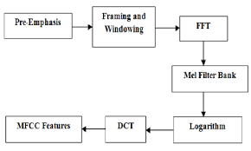

Fig . MFCC Block Diagram

EVALUATION MODEL
Model Evaluation is an integral part of the model development process. It helps to find the best model that represents our data and how well the chosen model will work in the future. Evaluating model performance with the data used for training is not acceptable in data science because it can easily generate overoptimistic and over fitted models. There are two methods of evaluating models in data science, Hold-Out and Cross-Validation. To avoid over fitting, both methods use a test set (not seen by the model) to evaluate model performance.
Performance of each classification model is estimated base on its averaged. The result will be in the visualized form. Representation of classified data in the form of graphs.
Accuracy is defined as the percentage of correct predictions for the test data. It can be calculated easily by dividing the number of correct predictions by the number of total predictions.

AUDIO FILE OVERVIEW
The sound excerpts are digital audio files in .wav format. Sound waves are digitized by sampling them at discrete intervals known as the sampling rate (typically 44.1kHz for CD-quality audio meaning samples are taken 44,100 times per second).
Each sample is the amplitude of the wave at a particular time interval, where the bit depth determines how detailed the sample will be also known as the dynamic range of the signal (typically 16bit which means a sample can range from 65,536 amplitude values).
What is Sampling and Sampling frequency?
In signal processing, sampling is the reduction of a continuous signal into a series of discrete values. The sampling frequency or rate is the number of samples taken over some fixed amount of time. A high sampling frequency results in less information loss but higher computational expense, and low sampling frequencies have higher information loss but are fast and cheap to compute.
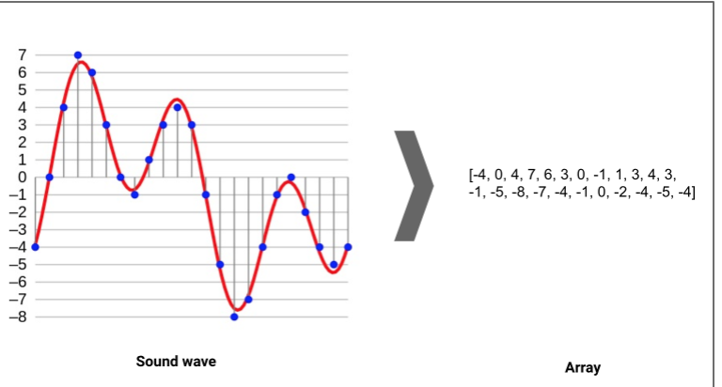

Audio Data Handling using Python

Sound is represented in the form of an audio signal having parameters such as frequency, bandwidth, decibel, etc. A typical audio signal can be expressed as a function of Amplitude and Time.
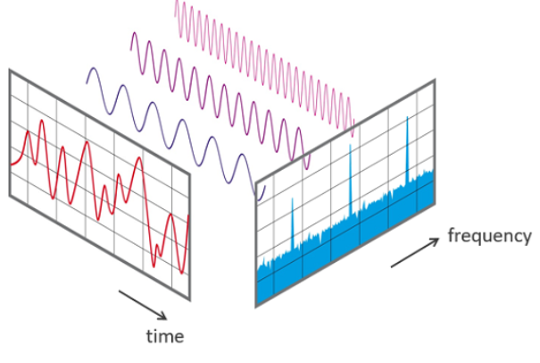
There are devices built that help you catch these sounds and represent it in a computer-readable format. Examples of these formats are
• wav (Waveform Audio File) format
• mp3 (MPEG-1 Audio Layer 3) format
• WMA (Windows Media Audio) format
A typical audio processing process involves the extraction of acoustics features relevant to the task at hand, followed by decision-making schemes that involve detection, classification, and knowledge fusion. Thankfully we have some useful python libraries which make this task easier.
Python Audio Libraries:
Python has some great libraries for audio processing like Librosa and PyAudio.There are also built-in modules for some basic audio functionalities.
We will mainly use two libraries for audio acquisition and playback:
1. Librosa
It is a Python module to analyze audio signals in general but geared more towards music. It includes the nuts and bolts to build a MIR(Music information retrieval) system. It has been very well documented along with a lot of examples and tutorials.
- Installation:
pip install librosa
or
conda install -c conda-forge librosa

UML DIAGRAMS:
UML DIAGRAMS
The Unified Modeling Language (UML) is used to specify, visualize, modify, construct and document the artifacts of an object-oriented software intensive system under development. UML offers a standard way to visualize a system's architectural blueprints, including elements such as:
- actors
- business processes
- (logical) components
- activities
- programming language statements
- database schemas, and
- Reusable software components.

UML combines best techniques from data modeling (entity relationship diagrams), business modeling (work flows), object modeling, and component modeling. It can be used with all processes, throughout the software development life cycle, and across different implementation technologies. UML has synthesized the notations of the Booch method, the Object-modeling technique (OMT) and Object-oriented software engineering (OOSE) by fusing them into a single, common and widely usable modeling language. UML aims to be a standard modeling language which can model concurrent and distributed systems.
Sequence Diagram:
Sequence Diagrams Represent the objects participating the interaction horizontally and time vertically. A Use Case is a kind of behavioral classifier that represents a declaration of an offered behavior. Each use case specifies some behavior, possibly including variants that the subject can perform in collaboration with one or more actors. Use cases define the offered behavior of the subject without reference to its internal structure. These behaviors, involving interactions between the actor and the subject, may result in changes to the state of the subject and communications with its environment. A use case can include possible variations of its basic behavior, including exceptional behavior and error handling.
- Activity Diagrams-:
  - Activity diagrams are graphical representations of Workflows of stepwise activities and actions with support for choice, iteration and concurrency.In the Unified Modeling Language, activity diagrams can be used to describe the business and operational step-by-step workflows of components in a system. An activity diagram shows the overall flow of control.
Usecase diagram:
- UML is a standard language for specifying, visualizing, constructing, and documenting the artifacts of software systems.
- UML was created by Object Management Group (OMG) and UML 1.0 specification draft was proposed to the OMG in January 1997.
- OMG is continuously putting effort to make a truly industry standard.
- UML stands for Unified Modeling Language.
- UML is a pictorial language used to make software blue prints
Class diagram
The class diagram is the main building block of object-oriented modeling. It is used for general conceptual modeling of the systematic of the application, and for detailed modeling translating the models into programming code. Class diagrams can also be used for data modeling.[1] The classes in a class diagram represent both the main elements, interactions in the application, and the classes to be programmed.

In the diagram, classes are represented with boxes that contain three compartments:

The top compartment contains the name of the class. It is printed in bold and centered, and the first letter is capitalized.
The middle compartment contains the attributes of the class. They are left-aligned and the first letter is lowercase.
The bottom compartment contains the operations the class can execute. They are also left-aligned and the first letter is lowercase.

Use Case :
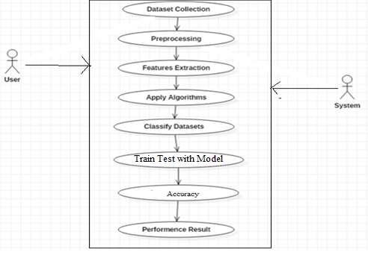

Class Diagram :

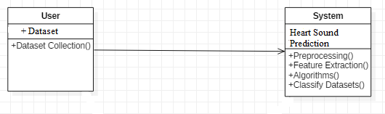

Sequence Diagram:
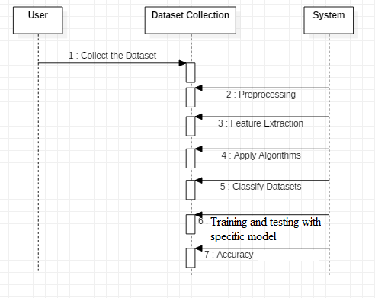

Activity Diagram:
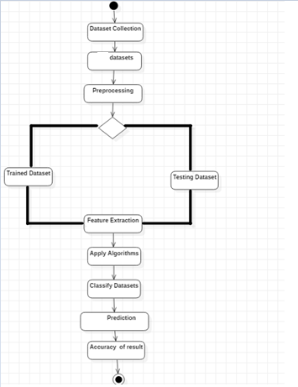

DATA FLOW DIAGRAM

LEVEL 0
Dataset Collection

Pre-processing

Feature Extraction

Trained & Testing dataset

LEVEL 1
Feature
Extraction
Pre-processing
Dataset collection

Apply
Algorithm
LSTM

CHAPTER- 5
SYSTEM IMPLEMENTATION

Domain Specification
Deep Learning
Deep learning is a computer software that mimics the network of neurons in a brain. It is a subset of machine learning and is called deep learning because it makes use of deep neural networks. The machine uses different layers to learn from the data. The depth of the model is represented by the number of layers in the model. Deep learning is the new state of the art in term of AI. In deep learning, the learning phase is done through a neural network.
Applications/ Examples of deep learning applications
AI in Finance: The financial technology sector has already started using AI to save time, reduce costs, and add value. Deep learning is changing the lending industry by using more robust credit scoring. Credit decision-makers can use AI for robust credit lending applications to achieve faster, more accurate risk assessment, using machine intelligence to factor in the character and capacity of applicants.
Underwrite is a Fintech company providing an AI solution for credit makers company. underwrite.ai uses AI to detect which applicant is more likely to pay back a loan. Their approach radically outperforms traditional methods.
AI in HR: Under Armour, a sportswear company revolutionizes hiring and modernizes the candidate experience with the help of AI. In fact, Under Armour Reduces hiring time for its retail stores by 35%. Under Armour faced a growing popularity interest back in 2012. They had, on average, 30000 resumes a month. Reading all of those applications and begin to start the screening and interview process was taking too long. The lengthy process to get people hired and on-boarded impacted Under Armour's ability to have their retail stores fully staffed, ramped and ready to operate.
At that time, Under Armour had all of the 'must have' HR technology in place such as transactional solutions for sourcing, applying, tracking and onboarding but those tools weren't useful enough. Under armour choose HireVue, an AI provider for HR solution, for both on-demand and live interviews. The results were bluffing; they managed to decrease by 35% the time to fill. In return, the hired higher quality staffs.

AI in Marketing: AI is a valuable tool for customer service management and personalization challenges. Improved speech recognition in call-center management and call routing as a result of the application of AI techniques allows a more seamless experience for customers.
For example, deep-learning analysis of audio allows systems to assess a customer's emotional tone. If the customer is responding poorly to the AI chatbot, the system can be rerouted the conversation to real, human operators that take over the issue.
Apart from the three examples above, AI is widely used in other sectors/industries.
Artificial Intelligence
Deep Learning
Machine Learning
ML

Difference between Machine Learning and Deep Learning
 | Machine Learning | Deep Learning
Data Dependencies | Excellent performances on a small/medium dataset | Excellent performance on a big dataset
Hardware dependencies | Work on a low-end machine. | Requires powerful machine, preferably with GPU: DL performs a significant amount of matrix multiplication
Feature engineering | Need to understand the features that represent the data | No need to understand the best feature that represents the data
Execution time | From few minutes to hours | Up to weeks. Neural Network needs to compute a significant number of weights
Interpretability | Some algorithms are easy to interpret (logistic, decision tree), some are almost impossible (SVM, XGBoost) | Difficult to impossible

When to use ML or DL?
In the table below, we summarize the difference between machine learning and deep learning.
 | Machine learning | Deep learning
Training dataset | Small | Large
Choose features | Yes | No
Number of algorithms | Many | Few
Training time | Short | Long
With machine learning, you need fewer data to train the algorithm than deep learning. Deep learning requires an extensive and diverse set of data to identify the underlying structure. Besides, machine learning provides a faster-trained model. Most advanced deep learning architecture can take days to a week to train. The advantage of deep learning over machine learning is it is highly accurate. You do not need to understand what features are the best representation of the data; the neural network learned how to select critical features. In machine learning, you need to choose for yourself what features to include in the model.
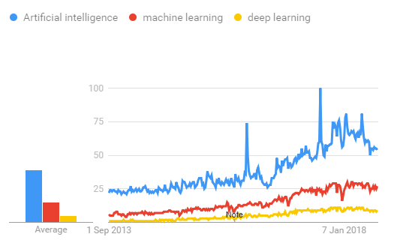
TensorFlow
the most famous deep learning library in the world is Google's TensorFlow. Google product uses machine learning in all of its products to improve the search engine, translation, image captioning or recommendations.
To give a concrete example, Google users can experience a faster and more refined the search with AI. If the user types a keyword a the search bar, Google provides a recommendation about what could be the next word.
Google wants to use machine learning to take advantage of their massive datasets to give users the best experience. Three different groups use machine learning:
- Researchers
- Data scientists
- Programmers.
They can all use the same toolset to collaborate with each other and improve their efficiency.
Google does not just have any data; they have the world's most massive computer, so TensorFlow was built to scale. TensorFlow is a library developed by the Google Brain Team to accelerate machine learning and deep neural network research.
It was built to run on multiple CPUs or GPUs and even mobile operating systems, and it has several wrappers in several languages like Python, C++ or Java.
In this tutorial, you will learn
TensorFlow Architecture
Tensor flow architecture works in three parts:
- Pre processing the data
- Build the model
- Train and estimate the model
It is called Tensor flow because it takes input as a multi-dimensional array, also known as tensors. You can construct a sort of flowchart of operations (called a Graph) that you want to perform on that input. The input goes in at one end, and then it flows through this system of multiple operations and comes out the other end as output.
This is why it is called TensorFlow because the tensor goes in it flows through a list of operations, and then it comes out the other side.
Where can Tensor flow run?
TensorFlow can hardware, and software requirements can be classified into
Development Phase: This is when you train the mode. Training is usually done on your Desktop or laptop.
Run Phase or Inference Phase: Once training is done Tensorflow can be run on many different platforms. You can run it on
- Desktop running Windows, macOS or Linux
- Cloud as a web service
- Mobile devices like iOS and Android
You can train it on multiple machines then you can run it on a different machine, once you have the trained model.
The model can be trained and used on GPUs as well as CPUs. GPUs were initially designed for video games. In late 2010, Stanford researchers found that GPU was also very good at matrix operations and algebra so that it makes them very fast for doing these kinds of calculations. Deep learning relies on a lot of matrix multiplication. TensorFlow is very fast at computing the matrix multiplication because it is written in C++. Although it is implemented in C++, TensorFlow can be accessed and controlled by other languages mainly, Python.
Finally, a significant feature of Tensor Flow is the Tensor Board. The Tensor Board enables to monitor graphically and visually what TensorFlow is doing.
List of Prominent Algorithms supported by TensorFlow
- Linear regression: tf. estimator .Linear Regressor
- Classification :tf. Estimator .Linear Classifier
- Deep learning classification: tf. estimator. DNN Classifier
- Booster tree regression: tf.estimator.BoostedTreesRegressor
- Boosted tree classification: tf.estimator.BoostedTreesClassifier

PYTHON OVERVIEW
Python is a high-level, interpreted, interactive and object-oriented scripting language. Python is designed to be highly readable. It uses English keywords frequently where as other languages use punctuation, and it has fewer syntactical constructions than other languages.

- Python is Interpreted: Python is processed at runtime by the interpreter.You do not need to compile your program before executing it. This is similar to PERL and PHP.

- Python is Interactive: You can actually sit at a Python prompt and interactwith the interpreter directly to write your programs.

- Python is Object-Oriented: Python supports Object-Oriented style ortechnique of programming that encapsulates code within objects.

- Python is a Beginner's Language: Python is a great language for thebeginner-level programmers and supports the development of a wide range of applications from simple text processing to WWW browsers to games.

History of Python
Python was developed by Guido van Rossum in the late eighties and early nineties at the National Research Institute for Mathematics and Computer Science in the Netherlands.
Python is derived from many other languages, including ABC, Modula-3, C, C++, Algol-68, SmallTalk, Unix shell, and other scripting languages.
Python is copyrighted. Like Perl, Python source code is now available under the GNU General Public License (GPL).
Python is now maintained by a core development team at the institute, although Guido van Rossum still holds a vital role in directing its progress.

Python Features

Python's features include:

- Easy-to-learn: Python has few keywords, simple structure, and a clearlydefined syntax. This allows the student to pick up the language quickly.

- Easy-to-read: Python code is more clearly defined and visible to the eyes.

- Easy-to-maintain: Python's source code is fairly easy-to-maintain.

- A broad standard library: Python's bulk of the library is very portable andcross-platform compatible on UNIX, Windows, and Macintosh.

- Interactive Mode: Python has support for an interactive mode which allowsinteractive testing and debugging of snippets of code.

- Portable: Python can run on a wide variety of hardware platforms and has thesame interface on all platforms.

- Extendable: You can add low-level modules to the Python interpreter. Thesemodules enable programmers to add to or customize their tools to be more efficient.

- Databases: Python provides interfaces to all major commercial databases.

- GUI Programming: Python supports GUI applications that can be created andported to many system calls, libraries, and windows systems, such as Windows MFC, Macintosh, and the X Window system of Unix.

- Scalable: Python provides a better structure and support for large programsthan shell scripting.

Apart from the above-mentioned features, Python has a big list of good features, few are listed below:

- IT supports functional and structured programming methods as well as OOP.

- It can be used as a scripting language or can be compiled to byte-code for building large applications.

- It provides very high-level dynamic data types and supports dynamic type checking.

- IT supports automatic garbage collection.

- It can be easily integrated with C, C++, COM, ActiveX, CORBA, and Java.

Python is available on a wide variety of platforms including Linux and Mac OS X. Let's understand how to set up our Python environment.
Platform
ANACONDA NAVIGATOR
Anaconda Navigator is a desktop graphical user interface (GUI) included in Anaconda distribution that allows you to launch applications and easily manage conda packages, environments and channels without using command-line commands. Navigator can search for packages on Anaconda Cloud or in a local Anaconda Repository. It is available for Windows, mac OS and Linux.

Why use Navigator?
In order to run, many scientific packages depend on specific versions of other packages. Data scientists often use multiple versions of many packages, and use multiple environments to separate these different versions.
The command line program conda is both a package manager and an environment manager, to help data scientists ensure that each version of each package has all the dependencies it requires and works correctly.
Navigator is an easy, point-and-click way to work with packages and environments without needing to type conda commands in a terminal window. You can use it to find the packages you want, install them in an environment, run the packages and update them, all inside Navigator.

WHAT APPLICATIONS CAN I ACCESS USING NAVIGATOR?
The following applications are available by default in Navigator:
- Jupyter Lab
- Jupyter Notebook
- QT Console
- Spyder
- VS Code
- Glue viz
- Orange 3 App
- Rodeo
- RStudio
Advanced conda users can also build your own Navigator applications

How can I run code with Navigator?
The simplest way is with Spyder. From the Navigator Home tab, click Spyder, and write and execute your code.
You can also use Jupyter Notebooks the same way. Jupyter Notebooks are an increasingly popular system that combine your code, descriptive text, output, images and interactive interfaces into a single notebook file that is edited, viewed and used in a web browser.

What’s new in 1.9?
- Add support for Offline Mode for all environment related actions.
- Add support for custom configuration of main windows links.
- Numerous bug fixes and performance enhancements.

TESTING
Software testing is an investigation conducted to provide stakeholders with information about the quality of the product or service under test. Software Testing also provides an objective, independent view of the software to allow the business to appreciate and understand the risks at implementation of the software. Test techniques include, but are not limited to, the process of executing a program or application with the intent of finding software bugs.
Software Testing can also be stated as the process of validating and verifying that a software program/application/product:
- Meets the business and technical requirements that guided its design and Development.
- Works as expected and can be implemented with the same characteristics.

CHAPTER- 6
TESTING

TESTING METHODS
Functional Testing

Functional tests provide systematic demonstrations that functions tested are available as specified by the business and technical requirements, system documentation, and user manuals.
Functional testing is centered on the following items:
- Valid messages: Identified classes of valid messages must be accepted.
- Invalid messages: Identified classes of invalid messages must be rejected.
- Functions: Identified functions must be exercised.
- Output: Identified classes of application outputs must be exercised.
- Systems/Procedures: Interfacing systems or procedures must be invoked.

Integration Testing

Software integration testing is the incremental integration testing of two or more integrated software components on a single platform to produce failures caused by interface defects.
TEST CASES
SL # | TEST CASE NAME | DESCRIPTION | STEP NO | ACTION TO BE TAKEN (DESIGN STEPS) | EXPECTED (DESIGN STEP) | Test Execution Result ( PASS/FAIL)
1 | Excel Sheet verification | Objective:  There should be an excel sheet. Any number of rows can be added to the sheet. | Step 1 | Excel sheet should be available | Excel sheet is available | Pass
 |  |  | Step 2 | Excel sheet is created based on the template | The excel sheet should always  be based on the template | Pass
 |  |  | Step 3 | Changed the name of excel sheet | Should not make any modification on the name of excel sheet | Fail
 |  |  | Step 4 | Added 505 or above records | Can add any number of records | Pass

CHAPTER- 7
RESULTS

SCREEN SHORTS :
To run project double click on ‘run.bat’ file to get below screen
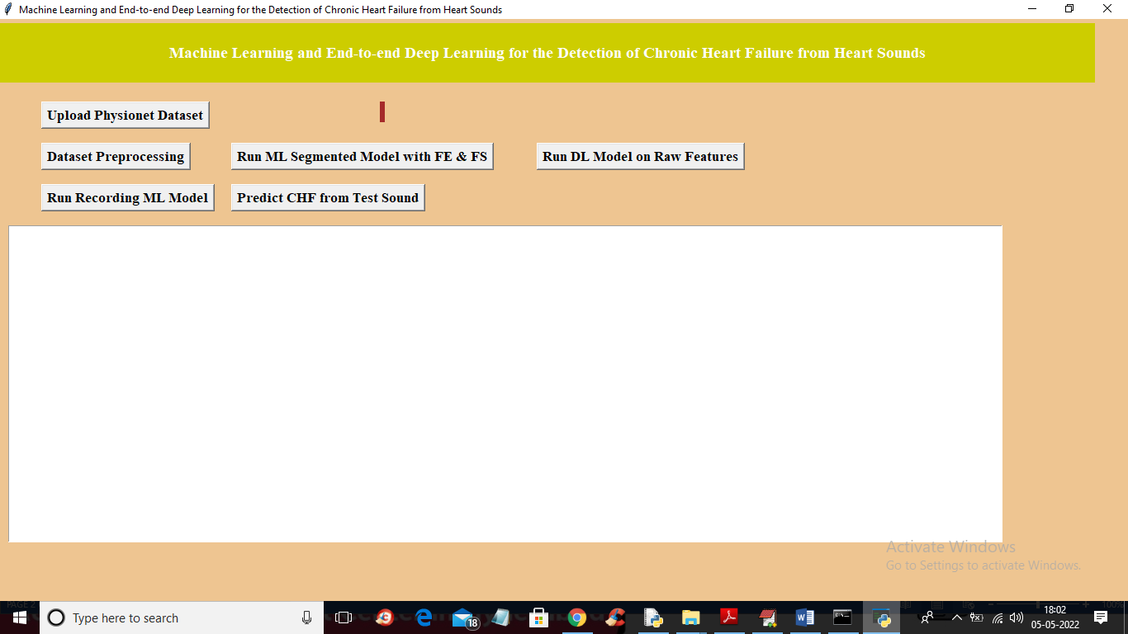
In above screen click on ‘Upload Physionet Dataset’ button to upload dataset
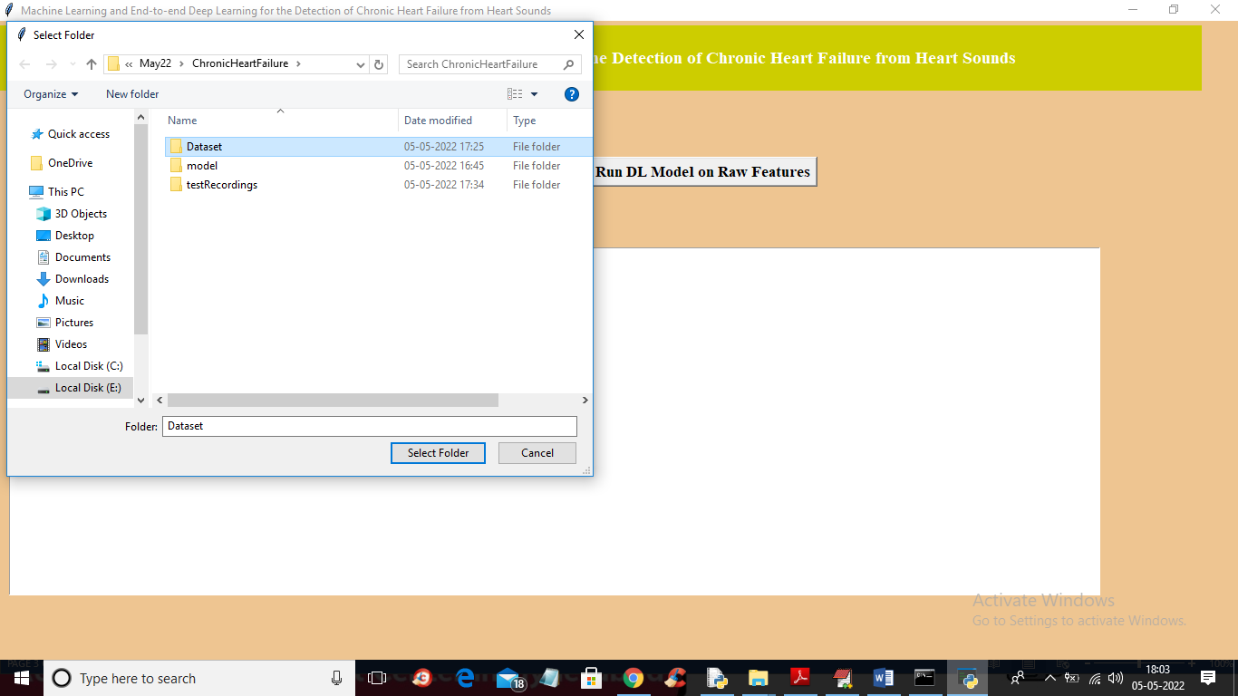
In above screen selecting and uploading ‘Dataset’ folder and then click on ‘Select Folder’ button to load dataset and to get below output
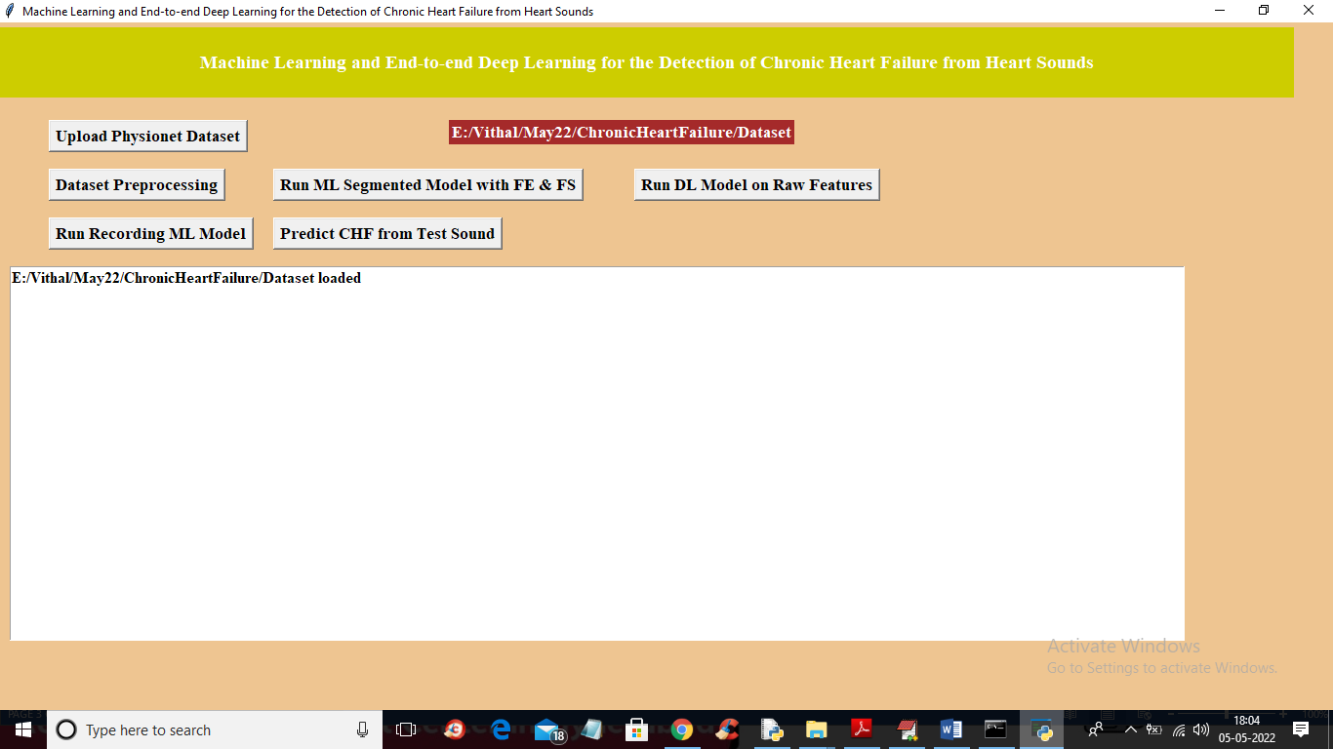
In above screen dataset loaded and now click on ‘Dataset Preprocessing’ button to read all dataset file and then extract features from it
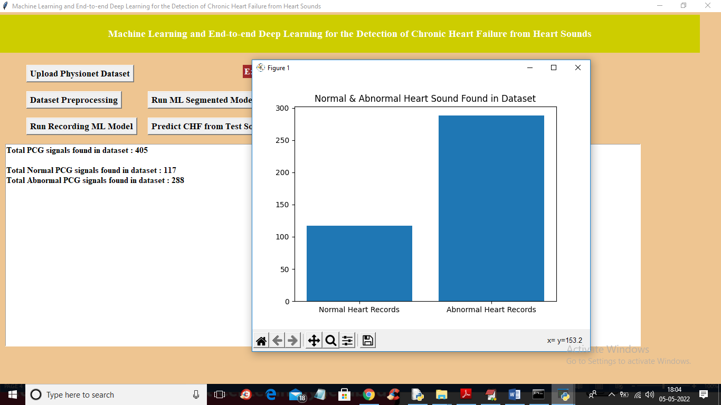
In above screen we can see dataset contains 405 heart sound files from 405 different person and 117 are the Normal sound and 288 are abnormal and in graph x-axis represents normal or abnormal and y-axis represents number of persons for normal or abnormal. Now close above graph and then click on ‘Run ML Segmented Model with FE & FS’ button to train Classic ML segmented model on above dataset and get below output
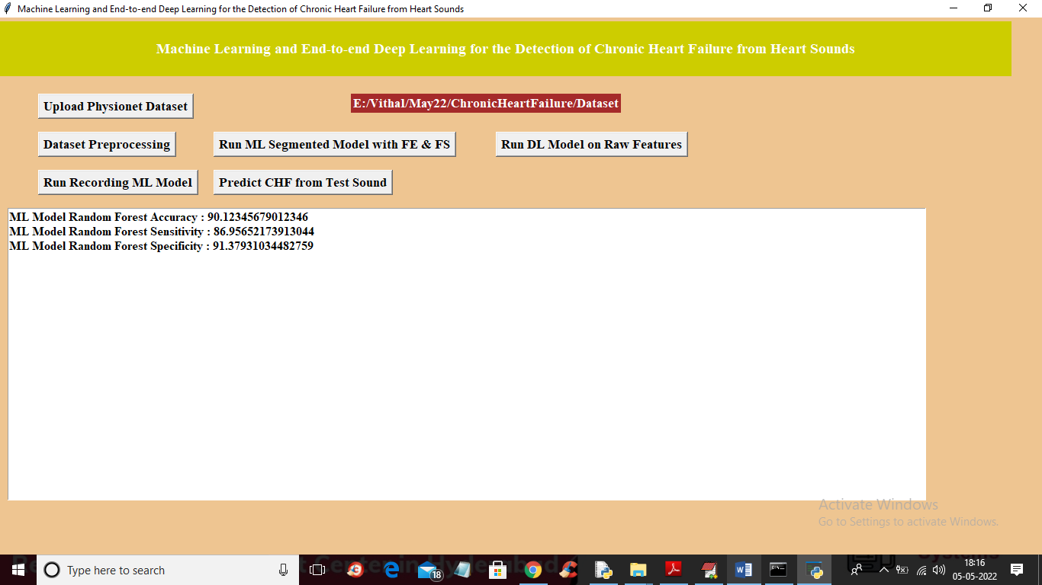
In above screen with Classic ML we got 90% accuracy and now click on ‘Run DL Model on Raw Features’ to get below output
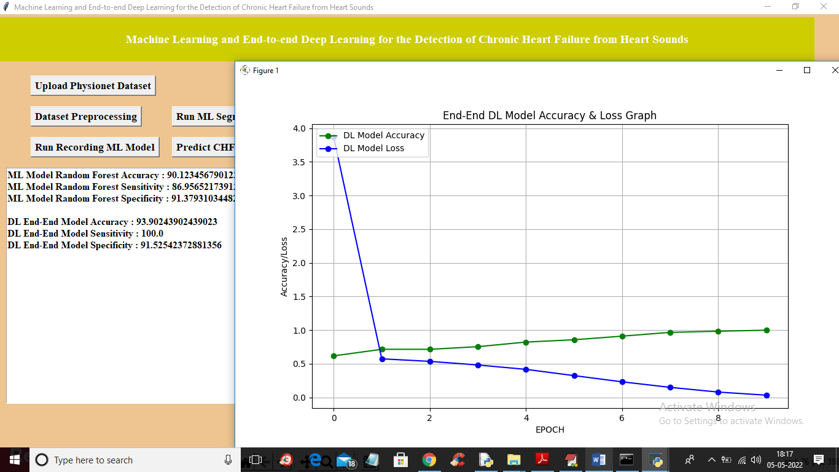
In above screen with DL model we got 93% accuracy and in graph x-axis represents epoch or iterations and y-axis represents accuracy or loss values and green line represents accuracy and blue line represents LOSS and we can see with each increasing epoch accuracy got increase and loss got decrease and now close above graph and then click on ‘Run Recording Model’ button to get below output
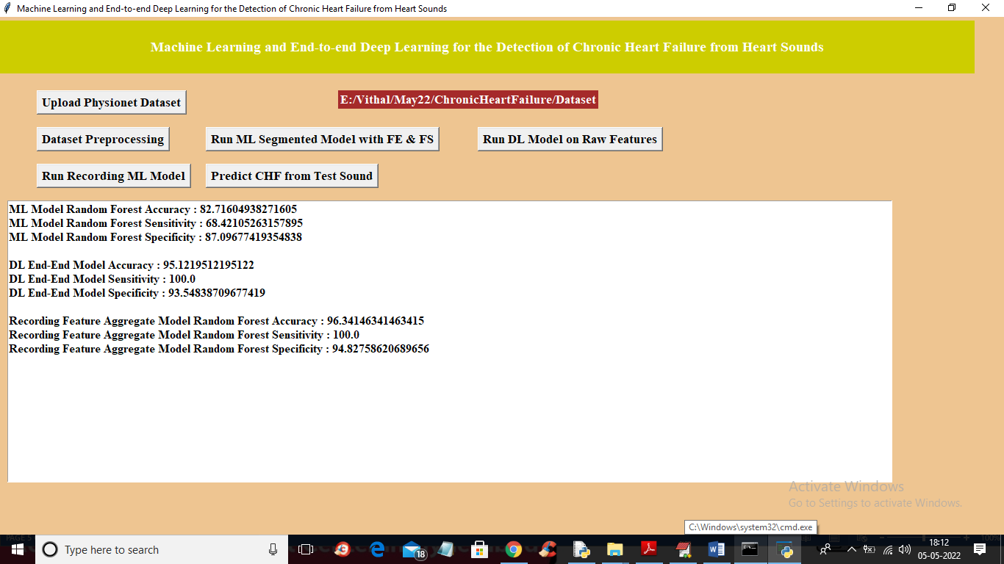
In above screen with recording model we got 96% accuracy and we can see all algorithms performance graph in below screen
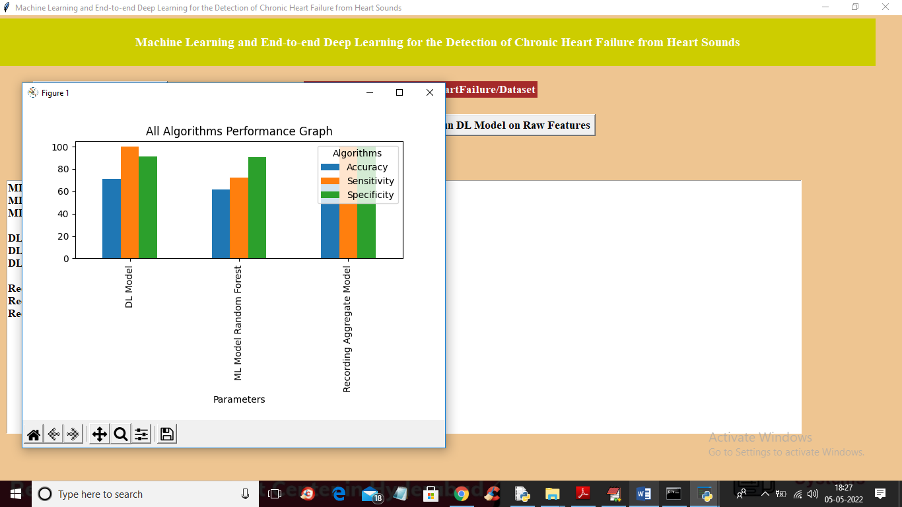
In above graph x-axis represents algorithm names and y-axis represents accuracy, sensitivity and specificity and in all algorithms Recording model has got high accuracy. Now close above graph and then click on ‘Predict CHF from Test Sound’ button to upload test sound file and get predicted output as Normal or Abnormal
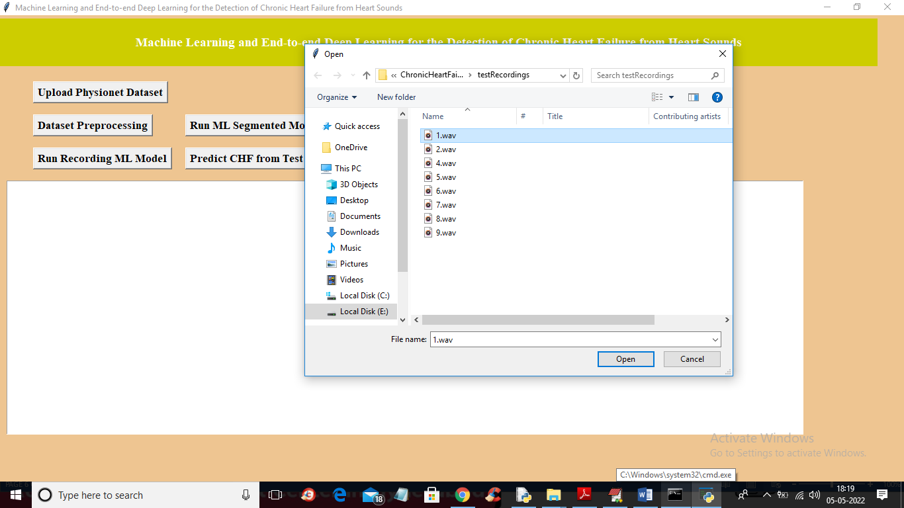
In above screen selecting and uploading ‘1.wav’ file and then click on ‘Open’ button to get below output
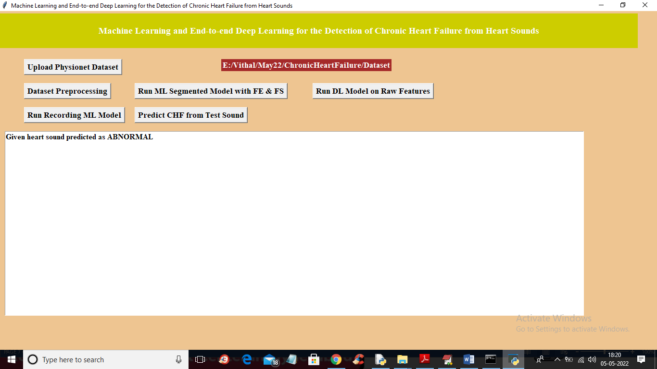
In above screen uploaded heart sound file predicted as ABNORMAL and similarly you can upload other files and test
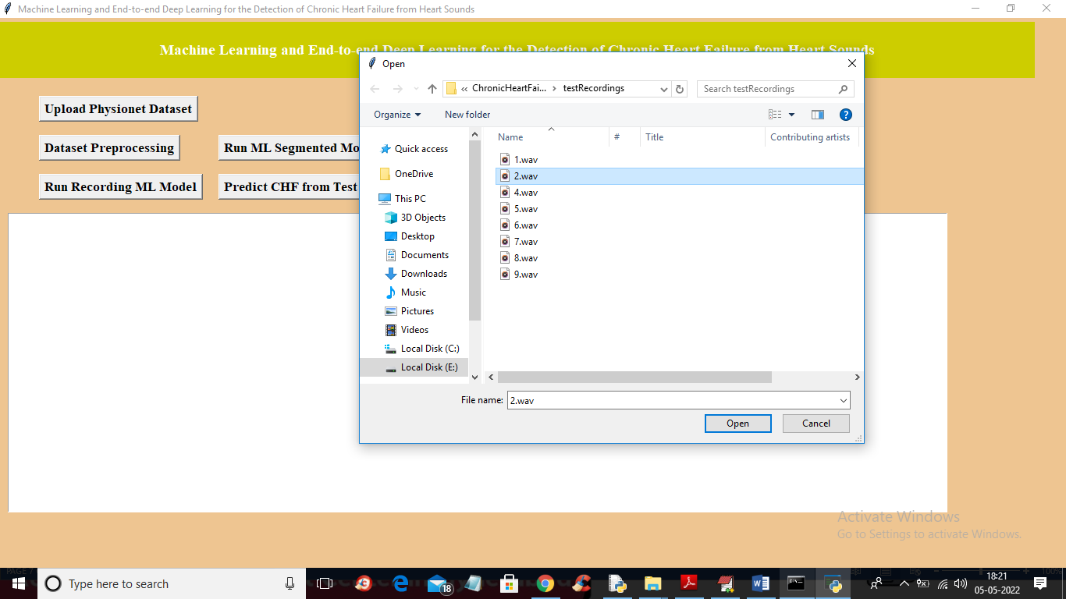
For 2.wav’ file below is the output
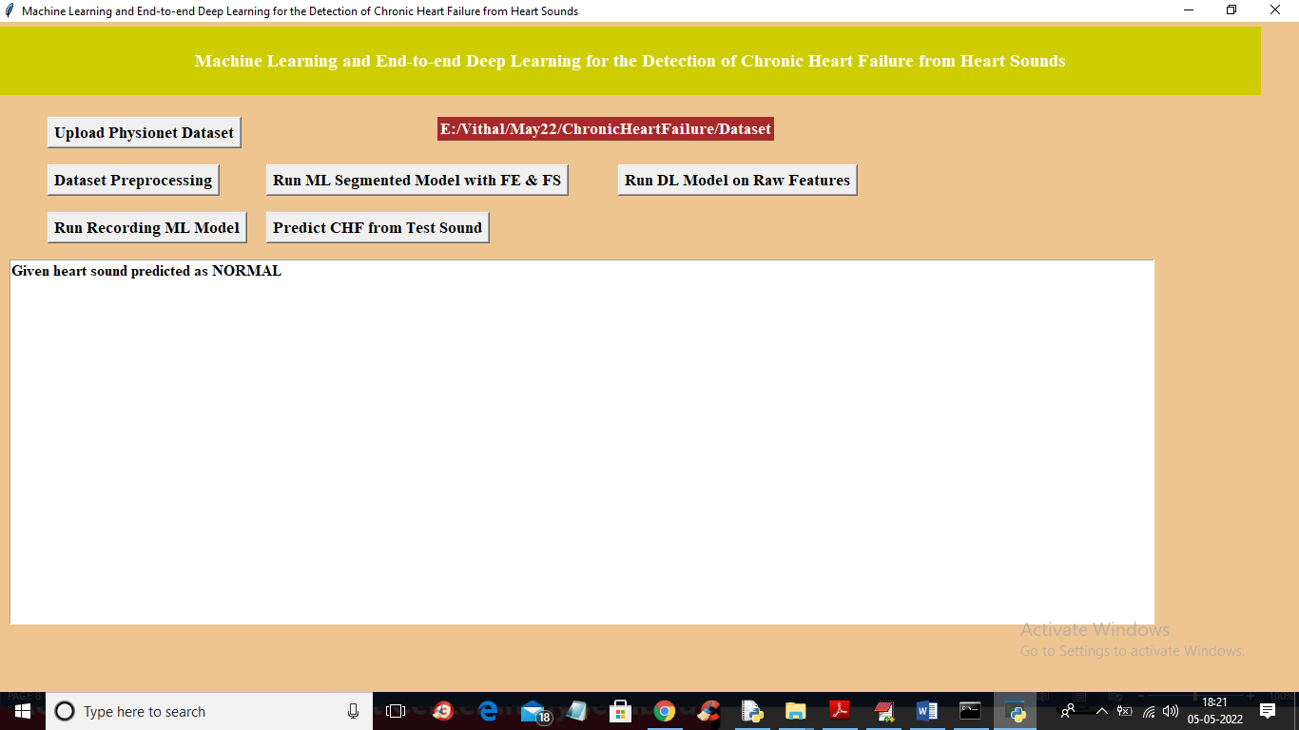

CHAPTER-8
CONCLUSION

CONCLUSION
In this developed algorithm, a deep learning-based classification technique is applied to classify the PCG recorded heart sounds as normal/abnormal also in abnormal subtype as murmur, artifact and extrasystole.MFCC is used to remove the noise that gets recorded along with the heart sound features. Various statistical features are extracted from filtered heart sound signals. In the proposed work, the features were strategically considered which are likely to be affected during an abnormal heart functioning. Those features improved the performance of deep learning algorithms in terms of time complexity and accuracy. The proposed method achieved 94.4% accuracy for abnormal and normal heart sound classification when tested on heart sound database. The proposed model of automated diagnosis shows high accuracy with low time complexity as compared to existing method ofclassification.

REFERENCES
1. Mendis S, Puska P, Norrving B, World Health Organization (2011) Global atlas on cardiovascular disease prevention and control (PDF). World Health Organization in collaboration with the World Heart Federation and the World Stroke Organization, pp 3–18. ISBN: 978-92-4-156437-3
2. Wilks S (1883) Evolution of the stethoscope. Popular Science 22(28):488–491
3. Leatham A (1975) Auscultation of the heart and phonocardiography. Churchill Livingstone, London
4. Azmy MM (2015) Classification of normal and abnormal heart sounds using new mother wavelet and support vector machines. In: 2015 4th international conference on electrical engineering (ICEE), Boumerdes, pp 1–3. https://doi.org/10.1109/intee.2015. 7416684. December 2015
14. Vadicherla D, Sonawane S (2013) Decision support system for heart disease based on sequential minimal optimization in support vector machine. Int J Eng Sci Emerg Technol 4(2):19–26
15. Kumar D, Carvalho P, Antunes M, Paiva RP, Henriques J (2010) Heart murmur classification with feature selection. In: 2010 annual international conference of the IEEE engineering in medicine and biology, Buenos Aires, 2010, pp 4566–4569
16. Guraksin GE, Uguz H (2011) Classification of heart sounds based on the least squares support vector machine. Int J InnovComput Inf Control 7(12):7131–7144
17. Hadi HM, Mashor MY, Mohamed MS, Tat KB (2008) Classification of heart sounds using wavelets and neural networks. In: 5th international conference on electrical engineering, computing science and automatic control, 2008. CCE 2008. Mexico City, 2008, pp 177–180. https://doi.org/10.1109/iceee.2008.4723403
- F. Plesinger et al., “Heart sounds analysis using probability assessment,” Physiological measurement, vol. 38, no. 8, p. 1685, 2017.
- C. Potes et al., “Ensemble of feature-based and deep learning-based classifiers for detection of abnormal heart sounds,” in 2016 Computing in Cardiology Conference (CinC). IEEE, 2016, pp. 621-624. [21] M. Zabihi et al., “Heart sound anomaly and quality detection using ensemble of neural networks without segmentation,” in 2016 Computing in Cardiology Conference (CinC). IEEE, 2016, pp. 613- 616. [22] E. Kay and A. Agarwal, “DropConnected neural networks trained on time-frequency and inter-beat features for classifying heart sounds,” Physiological measurement, vol. 38, no. 8, p. 1645, 2017.
- I. J. D. Bobillo, “A tensor approach to heart sound classification,” in 2016 Computing in Cardiology Conference (CinC). IEEE, 2016, pp. 629-632
- J. Rubin et al., “Classifying heart sound recordings using deep convolutional neural networks and mel-frequency cepstral coefficients,” in 2016 Computing in Cardiology Conference (CinC). IEEE, 2016, pp. 813-816.
- S. Choi, Z. Jiang, "Comparison of envelope extraction algorithms for cardiac sound signal segmentation," Expert Systems with Applications, vol. 34, no. 2, pp. 1056-1069, 2008.
- F. Eyben, F. Weninger, F. Gross, B Schuller, “Recent Developments in openSMILE, the Munich Open-Source Multimedia Feature Extractor,” In Proc. ACM Multimedia (MM), Barcelona, Spain, ACM, ISBN 978-1-4503-2404-5, pp. 835-838, October 2013.

